
Karsten Engsager
Senior advisor, Danish National Spacecenter, Danish Technical University (ke@space.dtu.dk).
Working with classical geodesy in the areas: Reference systems, Reference frames, Adjustment theory, Mappings, Transformations, Interpolation.

A HIGHLY ACCURATE WORLD WIDE ALGORITHM FOR THE TRANSVERSE MERCATOR MAPPING (ALMOST)

K. ENGSAGER¹, K. PODER²
¹ Danish National Space Center, Geodetic Department, Danish Technical University, Juliane Mariesvej 30, DK-2100 Copenhagen E, Denmark. ² DK-3650 Ølstykke, Denmark

Introduction

This presentation is in no way new or genius. It solely presents the ideas and developments from colleagues: König und Weise (1951). “Map Projections” Grafarend and Krumm (2006) appeared shortly before this paper was written, but some comments are included. The single steps in performing the mapping from geographical (geodetic) coordinates to Transverse Mercator coordinates (and reverse) are outlined but not proved. The formulas given are valid at high/low altitudes with only singularity at the equator 90 degrees from the central meridian.
It is our hope that this presentation will convince the reader that the Transverse Mercator projection is a useful tool for world wide presentations.

The Transverse Mercator mapping is a conformal mapping of the ellipsoid coordinates to a plane. Any mapping function satisfying the Cauchy-Riemann differential formula is conformal. It is therefore nearby to use series of complex functions to describe the Transverse Mercator projection. Some of the complex functions are given as Clenshaw sine summation where the coefficients are elaborated on the third flattening n which gives very efficient series. Our contribution is to extend these series from degree 4 to 7. Using series to degree 4 the accuracy is 0.03 mm up to 4400 km from the central meridian. Using the series to higher degree will increase this limit.

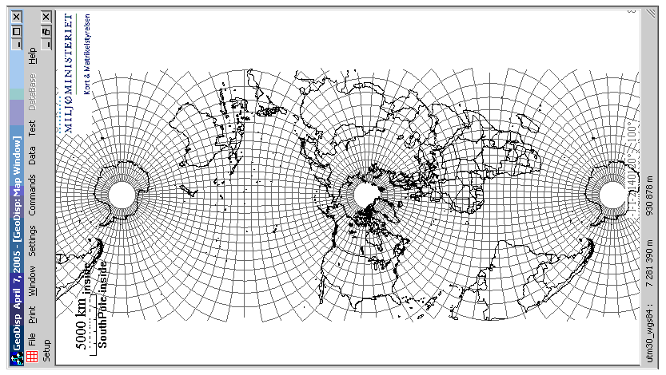

Coordinate designation

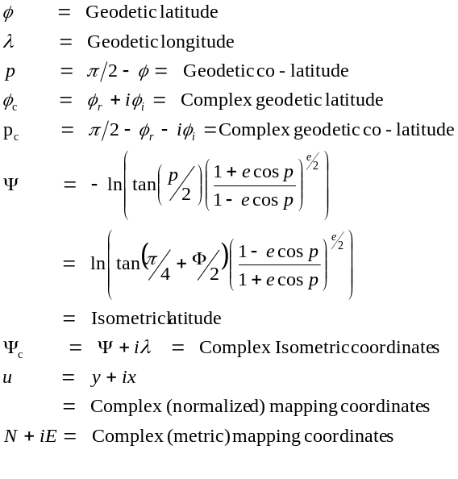
Ellipsoidal definition

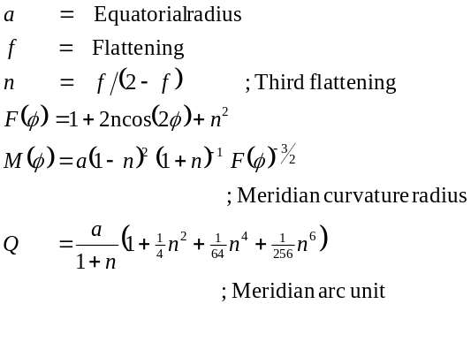
The size of some coefficients to the series expansions have been calculated using the derived value of n in the Geodetic Reference System 1980 (GRS80).

The meridian arc unit Q is the mean length of one radian of the meridian thus the length of the meridian quadrant is:
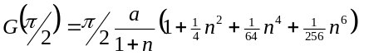
The last term being 0.1 10⁻¹⁸ shows the superiority of series expansion in powers of the third flattening n against using 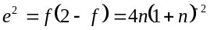as given in Grafarend and Krumm (2006) (8.40). Using the mean axis
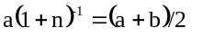for the scale furthermore improves the efficiency of the series (b is the minor axis).

Help functions
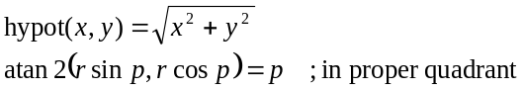
Clenshaw sine accumulation (simple or complex) is used in calculation of the series:
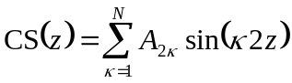
Details may be found in Poder and Engsager (1998).

Derivatives of a mapping function

The derivatives of a mapping function can be found as the complex differential with modulus m and argument g of the mapping function to the complex differential of isometric latitude and longitude. The simplification is possible because both systems are orthogonal and isometric.

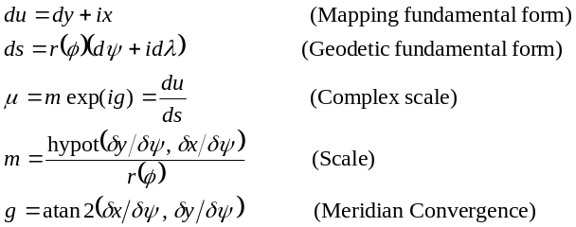

The Transverse Mercator mapping

The Transverse Mercator is basically a generalisation of the meridian to the plane:
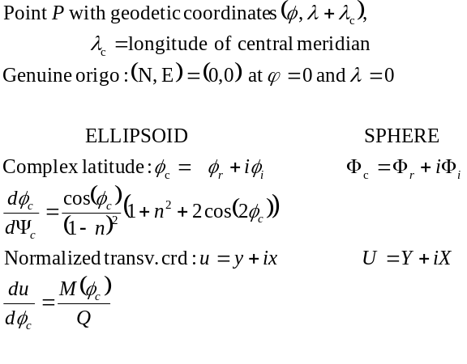

Mapping sequence for the Transverse Mercator mapping

The mapping for the Transverse Mercator is split up in several conformal mappings during the development of the mapping. This is done to ensure as efficient expansion of series and a simple development strategy. Finally some of the mappings are united again ending up with only three mappings:
- Ellipsoidal coordinates to the Soldner Sphere
- Soldner Sphere to Complex Gaussian coordinates
- Complex Gaussian coordinates to Transverse Mercator coordinates

Direct mapping
┌────────────────────────┐
│ φ,λ: Geodetic coord │
└────────────┬───────────┘
(1) ⇓ │ ⇑ (2)
┌────────────┴───────────┐
│ Φ,Λ: Soldner Sphere │
└────────────┬───────────┘
(3) ⇓ │ ⇑ (4)
┌────────────┴───────────┐
│ Y,X: Complex Gaussian coord. │
└────────────┬───────────┘
(5) ⇓ │ ⇑ (6)
┌────────────┴───────────┐
│ N,E: Transversal coord. │
└────────────────────────┘
Inverse mapping
Mapping Ellipsoid ⬅➔ Soldner Sphere

The Soldner Sphere is a pure parameter sphere of unity size. The Geodetic coordinates of the ellipsoid is mapped on the sphere with the simple and virtually unique mapping equations as shown below. Strictly speaking we should account for the Riemann leaves arising from the periodicity of the complex functions.
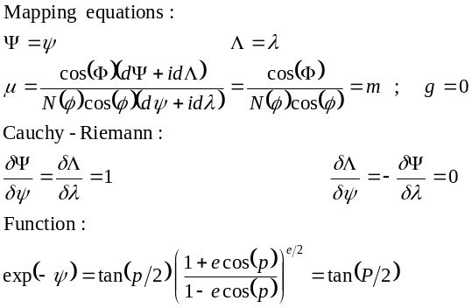

This may be reformulated into a Clenshaw sine summation:
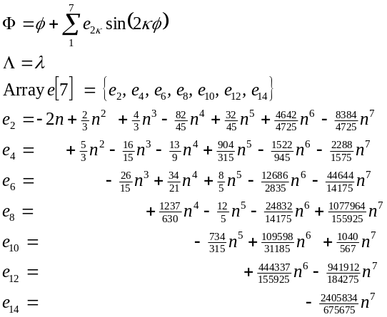
(1) Geodetic coordinates ➔ Soldner Sphere

The last coefficient is e₁₄ = -1.3 10⁻¹⁹
Limiting the series to n⁴ gives the last coefficient in e₈ = 1.6 10⁻¹¹

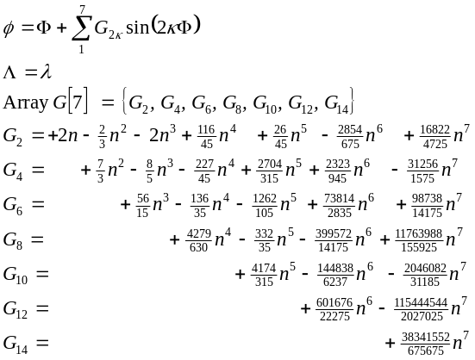
(2) Soldner Sphere ➔ Geodetic coordinates

The last coefficient is G₁₄ = 2.1 10⁻¹⁸
Limiting the series to n⁴ gives the last coefficient in G₈ = 5.4 10⁻¹¹

Soldner Sphere ⬅➔
Complex Gaussian coordinates

The Complex Gaussian coordinates gives a transverse mapping, where the central meridian is mapped with unity scale i.e. it behaves as if the central meridian is the “virtual equator” and the normal to the central meridian plane passing through the centre of the sphere is the “virtual rotation axis”. A point with the Gaussian coordinates (Φ, Λ) should be mapped to the Complex Gaussian coordinates Φ_{c} = Φ_{r} + iΦ_{i}.
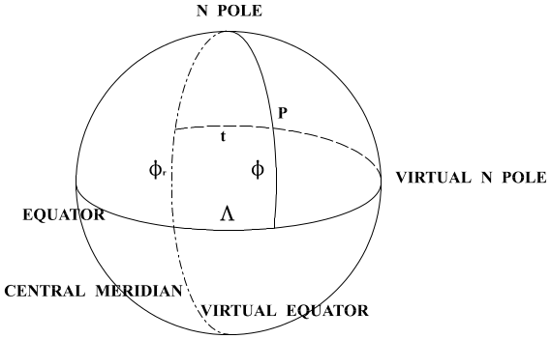

The figure shows the latitudes and the longitude and the auxiliary parameter t, which in fact is the virtual latitude, while Φ_{r} is the virtual longitude in a Mercator mapping, where the central meridian acts as the virtual equator and the virtual poles are found in the real equator 90 degrees from the central meridian.
The singularity at the (true) Poles is handled by using the atan2 function.

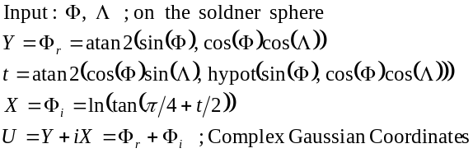(3) Soldner Sphere ➔ Complex Gaussian coordinates

The parameter t (atan2(…)) is crucial for the accuracy of the entire Transverse Mercator mapping. For geodetic purposes up with series expantion to degree 4 t up to 40° is acceptable giving 0.03 mm in accuracy. For cartographic purposes it is possible to go close 90° and still getting an accuracy of one meter.

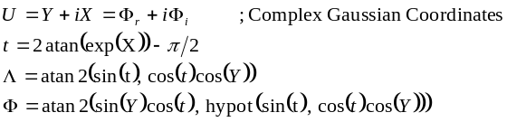(4) Complex Gaussian coordinates ➔ Soldner Sphere

Complex Gaussian coordinates
⬅➔
Transverse Coordinates

The Complex Gaussian coordinates are mapped to Transverse Coordinates in two steps via the Normalized Transverse Coordinates. The two Clenshaw summations have been reformulated to one which is presented below. Interested readers may find details in Poder and Engsager (1998). The normalized transversal coordinates are then scaled to Transversal Mercator coordinates.

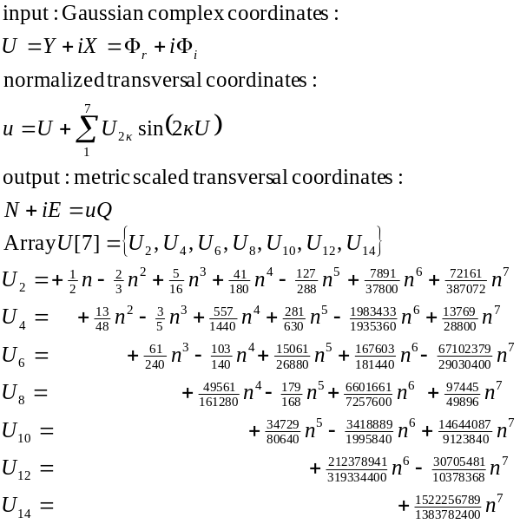(5) Complex Gaussian coordinates ➔ Transversal Mercator coordinates

The last coefficient is U₁₄ = 4.1 10⁻²⁰
Limiting the series to n⁴ gives the last coefficient in U₈ = 2.4 10⁻¹²

NB.: Clenshaw Complex sine summation is used in (5) and (6).

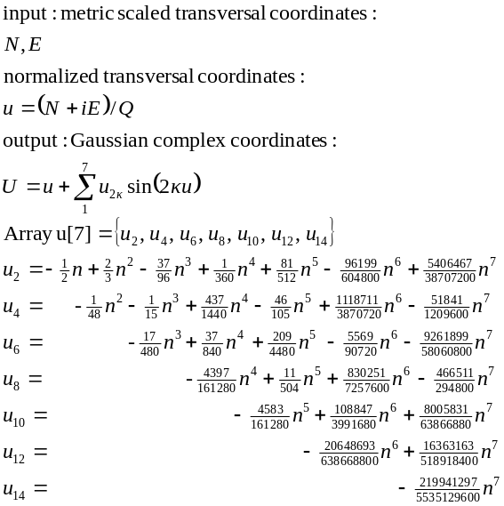(6) Transversal Mercator coordinates ➔ Complex Gaussian coordinates

The last coefficient is u₁₄ = -1.5 10⁻²¹
Limiting the series to n⁴ gives the last coefficient in u₈ = -2.2 10⁻¹³

Implementation details

All coordinates except the Transversal Mercator coordinates may be considered be angular units in radians. The Meridian arc unit Q is used to transform the Transverse Mercator coordinates into angular units called Normalized Transverse Mercator coordinates.

Using the scaled meridian arc unit Q_{m} instead introduce the scale in a simple way:
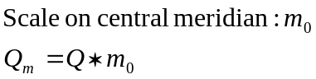

Accuracy check
Taking the difference between the input coordinates and the result of the backward_trf(forward_trf(input coordinates)) the accuracy may be checked against the accuracy required for transformation. In the figure below is the limit 0.03 mm shown at series to degree 4 and 5. This limit may be controlled in (3) by 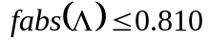 and in (4) by 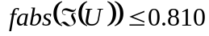 as a very coarse limit (i.e. 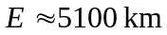). The limit is in fact a function of the latitude and longitude. For degree 5 the limit will be 1.144 (i.e. 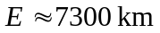).
An accuracy limit of 30 m will give a limiting factor of 2.290 (i.e. 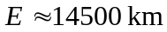).
The singularity points may be controlled by the limiting factor above or a coarser one.

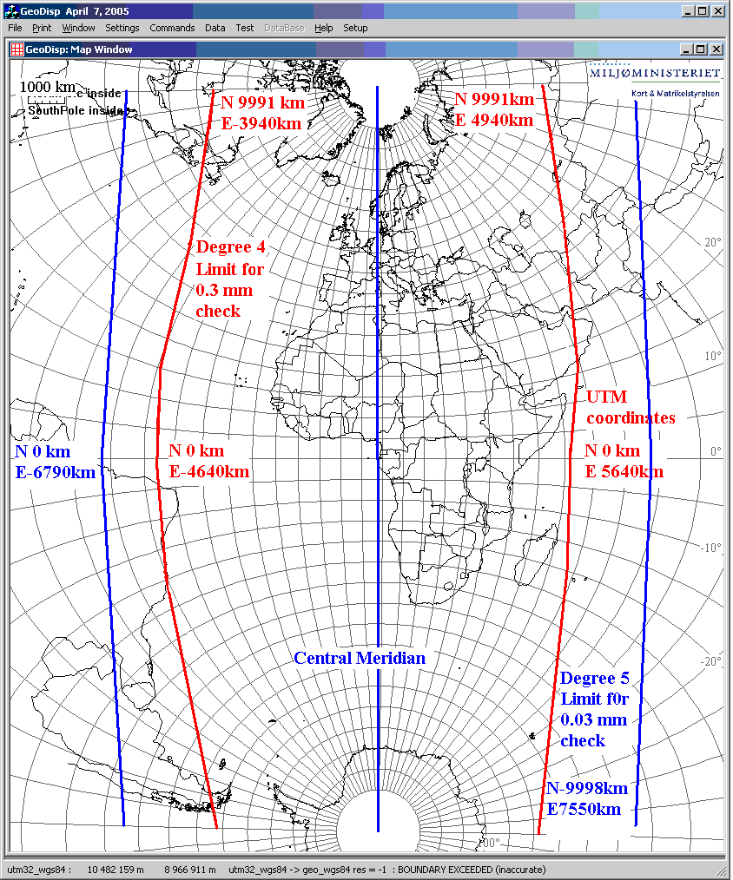
UTM zone 32 coordinates : E coordinate is given +E₀ (=500km)

Performance
The mapping implemented to 4th degree run on a PC with Intel Pentium 4 cpu 2.66 GHz makes more than 224000 transformations pr. second in accuracy checking mode: backward_trf(forward_trf((input coordinates)).
An implementation to 5th degree decreases the throughput to 222000. When the mapping is run trough our general transformation manager the throughput decreases by further 10%.

More convolutions
The formulas presented are valid for the latitude 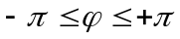 and for the longitude 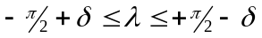, where δ may be related to the control setup above. When the input latitude goes beyond the limits it is forced to the interval by adding/subtracting κ2π to the latitude and the northing N is either increased or decreased by κ4Q_{m} . The reverse situation is handled in a similar way.

Conclusion

It has been demonstrated that it is possible in a fairly simple sequence of very efficient mappings to transform the geographical coordinates to Transversal Mercator Coordinates.

It has been pointed out that there is a substantial difference in expanding series in powers of the third flattening n against in powers of the eccentricity e². Due to the relation between the two parameters any series expansion may be reformulated to the other.

To illustrate the accuracy the size of some coefficients depending on the third flattening n have been calculated to the derived value of n in the Geodetic Reference System 1980 (GRS80).

Implementation details have also been given.

The C-code for the Transversal Mercator mapping is free and may be found on the homepage spacecenter.dk under Research/Geodesy/Mapping (the URL is not ready at writing time) or will be forwarded on request to ke@spacecenter.dk

Appendix

Scaled meridian arc length from equator to the latitude
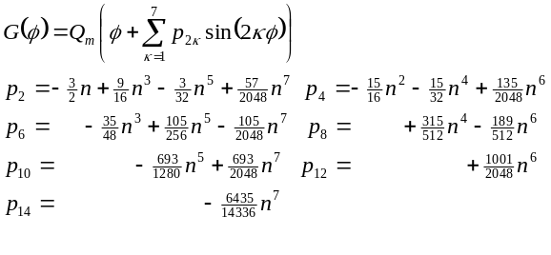The last coefficient is p₁₄ = 1.7 10⁻²⁰
Limiting the series to n⁴ gives the last coefficient in p₈ = 4.9 10⁻¹²

Latitude at the normalized arc length

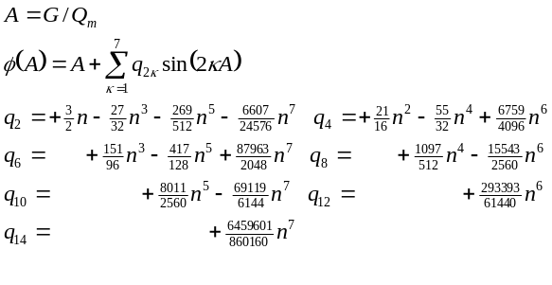
The last coefficient is q₁₄ = 2.8 10⁻¹⁹
Limiting the series to n⁴ gives the last coefficient in q₈ = 1.7 10⁻¹¹

Meridian convergence and local scale

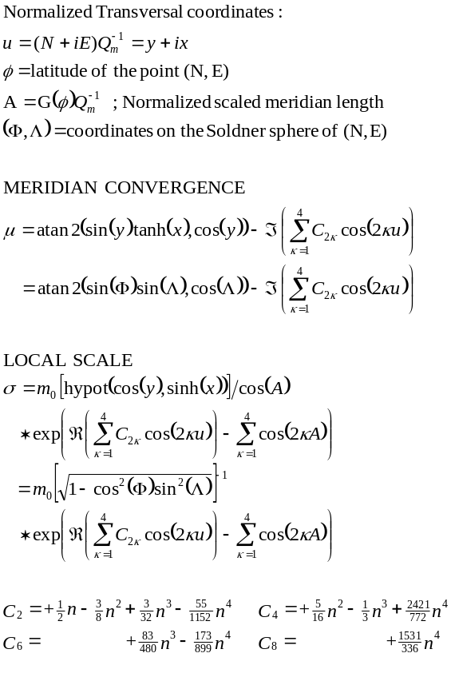
The last coefficient is C₈ = 3.6 10⁻¹¹ and in the Clenshaw summation is used both cosine and complex cosine.

References

Bomford, G (1962): Geodesy, second edition, Oxford

Bougayevskiy Lev M, Snyder John P (1995) Map Projections. A reference Manual. Taylor and Francis, London

Grarafend E.W., Krumm F.W. (2006): Map Projections. Springer, Berlin/Heidelberg/New York

Krüger L (1912): Konforme Abbildung des Erdellipsoids in der Ebene. Veröffentlichung des Königlisch Preuszischen Geodätischen Institutes. Neue Folge No. 52, Potsdam

König R, Weise K.H. (1951): Mathematische Grundlagen der Höheren Geodäsie und Kartographie, Erster Band, Springer, Berlin/Göttingen/Heidelberg

Poder Knud, Engsager Karsten (1998): Some Conformal Mappings and Transformations for Geodesy and Topographic Cartography. National Survey and Cadastre, Denmark, Publications 4. series vol. 6, Copenhagen

Richardus Peter, Adler Ron K (1972): Map projections, North Holland, Amsterdam

Journal of Geodesy (2004): The Geodesist’s Handbook 2004, Springer

